**Academy of Electrical and Computer Engineering (AECE) Minutes of Annual Business Meeting**

**Thursday, April 13, 2023**

**Members in Attendance:**

Geoff Akers Clay Melugin

Eric Ashinger Clay Merritt

Michael Basler Ed Midden Sharon Beermann-Curtin J. Derald Morgan Edward Bradley Dale Morse

Thomas Dalton Mark Nealon

Dan Dziedzic Gregory O’Neill

Alan Erickson Kenneth Owens, Jr.

Kelvin Erickson James Paunicka

James Fricke Joe Ruder

John Haake Donald Shaw

Mark Hoffman Ward Silver

Ron Kochanowicz John Skain

Vince Kunderman George Tomazi

Leonard Laskowski Thomas Van Doren

Dennis Leitterman Roger Volk

Kevin McEnery Steve Watkins

The annual meeting of the Academy of Electrical and Computer Engineering was held Thursday, April 13, 2023, and called to order at 8:15 a.m. The meeting was held at the Comfort Suites Conference Center.

President Leonard Laskowski chaired the meeting.

Dr. Jonathan Kimball, ECE Department Chairman welcomed the Academy members to the meeting.

### Missouri S&T Representatives attending:

Dr. Kurt Kosbar, Scholarship Committee Chair

Dr. Jonathan Kimball, Department Chair of Electrical and Computer Engineering Dr. Kelvin Erickson, Undergraduate Department Chair of Electrical Engineering Dr. David Borrok, Dean of Engineering and Computing

Lara Turek, Executive Director of Development

# Departmental Reports

* 1. **Scholarship Recipient Updates** – Dr. Kurt Kosbar
     + A total of $67,540 were awarded this year.
     + The Miner Match accounts provided twenty students support with a total distribution of $59,763.
     + Twenty-two students received the funds, including three students that also received the endowments.
     + Recipients of the scholarship funds must have a strong GPA, be making adequate progress toward their EE or CpE degree program, and earn less than $40K (as reported on the federal student aid form
  2. **Electrical and Computer Engineering Department Updates** – Dr. Jonathan Kimball
     + **Dr**. Kimball presented “My Vision: A Program That Serves Future Alumni.”
     + **Highlights on strengthening student organizations, professor**-student relationships, including existing alumni and industry supporters, and engaging students in effective research programs to create successful engineers in the field.
     + Enrollment is down, due to a significant drop in international students being able to enroll during the pandemic.
     + Current enrollment numbers:
       - CpE Programs-288 BS, 21 MS, and 14 PhDs
       - EE Programs-403 BS, 42 MS, and 50 PhDs
     + Accelerated BS/MS program enrollment is showing growth.
     + Awards, Honors and Accolades for ECE faculty and students were shared.
     + Strategic Plan
       - Reported changes are anticipated in distance education, non-thesis MS programs, and accelerated BS/MS
       - Potential DURF Initiative modeled after successful MAE program.
  3. **College of Engineering & Computing Updates** – Dr. David Borrok
     + Dr. Borrok reported there are 128 tenured and tenure track faculty and 34 Non-tenure track faculty members (28 teaching; 6 research)
     + 51 faculty with endowed professorships or named teaching fellowships.
     + $249,500 in annual expenditures per tenured or tracked faculty members.
     + He highlighted recent leadership changes within the department, notably for ECE:
       - Dr. Mehdi Ferdowsi named Interim Associate Dean for Research
       - Dr. Jonathan Kimball named Chair of the ECE department.
     + He also mentioned that admissions to the ECE programs have moved to direct admission to the department, and that the freshman engineering program no longer exists.
     + A new tuition structure that consolidates base tuition, course fees, and IT fees into one flat-based rate.
     + Fall 2023, engineering is $8,500/semester (for students enrolled between 12 to 18 hours).
     + New initiatives were also presented, Bio-X to increase biology and health-related research and education on campus.
     + Also, a new BS-degree in Biomedical Engineering, PhD program in Bioengineering were mentioned, ready to start by Spring 2024.
  4. **Undergraduate Program Updates** – Dr. Kelvin Erickson
     + Reported changes in the Math sequence- Calc I, Calc II, Diff Eq, then Calc III.
     + Diff Eq is now a co-requisite for EE 2100.
     + Proposal to replace EE 2200 with continuous linear systems using Matlab for half the lab.
     + Changes to EE 2200 are also being discussed to better suite CpE program majors.
  5. **University Development Update** – Lara Turek
     + Turek updated Academy members on the new Arrival District Construction which includes an Innovation Lab, Welcome Center, and Parking Garage
     + She reported the Innovation Lab is planned to be completed this Fall 2023
     + Welcome Center construction will start in June of this year, and the parking garage will be completed soon also.

# Student Design Team and Scholarship Recipients Presentations

* 1. Austin King and Josh Kozlowski from M-SAT Research Team presented on their project to create a satellite that would be able to track the relative position and velocity of objects in space. The team works with professionals from AFRL and NASA and will be launching one of their created satellites into space January 2024!
  2. Team Micro, Senior Design Team presented on their project which consisted of a beverage dispenser that they incorporated with a credit card reader in the front in order to charge a drink to a customer.
  3. Christian Winingar, a scholarship recipient, presented a presentation to the members.
     + Christian is from Kansas City, MO.
     + He started the EE program at S&T in August 2020.
     + Active member in Sigma Nu Fraternity, IEEE/HKN, Interfraternity Council, and works for the rec center as sports data recorder.
     + His goals after receiving his BS degree are full-time employment and returning to school to earn his MBA or a MS Engineering Management.

# Academy Business Meeting

President Leonard Laskowski called the business meeting to order 12:55 pm welcoming the new inductees and recognizing Sarah Sullivan and Joni Matlock from S&T’s ECE department for their help getting everything planned and arranged.

### Approval of April 2022 Business Minutes

* Roger Volk moved to approve the minute with the exception to correct the spelling of Lara Turek’s (S&T Development representative’s name), Don Shaw seconded, and the minutes were approved.

### Vice President Report, Panel Discussion-Mark Nealon

* + - 35 students attended HKN Panel discussion.
    - Reported the panel was slow at first, due to no prearranged questions for panel to answer.
    - Sharon Beermann-Curtin questioned the students about what they thought corporate life would be like in the engineering field, which prompted more questions from the students to the panel guests.
  1. **Treasure’s report**

## TREASURER'S REPORT

INCOME AND EXPENDITURES (Fund R2897)- 3/1/22 THRU 2/28/23

**BALANCE FORWARD** - **3/1/22**

**INCOME**

Gifts - Member and Company Match

**Total Income**

**TOTAL AVAILABLE FUNDS**

**EXPENDITURES**

Academy Operations - Postage

Net Business Meeting and Meal Expenses Scholarships (None from operating account) Scholarships - Miner Match Transfer Student Orgs, Travel Funding {None - Covid) **Total Expenditures**

**BALANCE ENDING** - **2/28/23**

$30,S10.00

**S30,s10.oo**

$127.14

$1778.79 1

$0.00

$60,000.00

$0.00

**S61,905.93**

**$71,819.41**

**$102,329.41**

**�40,423.48**

**MISSOURI**

**8**

1 This expenditure value is reduced by the Paid Meals receipts that were paid by members

**S&T**

I I I I I I I I I I I I I I I I I I I I I I I I I I I I I I I I I I I I I I I I

## TREASURER'S REPORT

AECE ENDOWMENTS- 3/1/22 THRU 2/28/23

|  |  |  |  |  |  |  |  |  |
| --- | --- | --- | --- | --- | --- | --- | --- | --- |
|  | **FUND** | **BALANCE**  **FORWARD** | **INCOME**  & **DISTRIB.** | **AWARDS/**  **EXPENSES** | **ENDING**  **BALANCE** | **ENDOW.**  **PRINCIPAL** | **MAR-2023**  **AWARDS1** |  |
| **AECE (RAJ57)** | **($929.65)** | **$5,813.57** | **$0.00** | **$4,883.92** | **$174K** | **$4,883.00** |  |
| **AECEI (RDC96)** | **($576.70)** | **$1,744.46** | **$0.00** | **$1,167.76** | **$52K** | **$1,167.00** |  |
| **AECE** II  **(RDC98)** | **($97.55)** | **$1,824.93** | **$0.00** | **$1,727.38** | **$55K** | **$1,727** |  |
|  | **AECE LAB (RDWG2l** | **$8,022.11** | **$1,940.73** | **$0.00** | **$9,962.84** | **$55.5K** | **$0.00** |  |

1 Awards were made after the AECE 3/1/22 thru 2/28/23 Fiscal Year MISSOURI

**S&T**

9

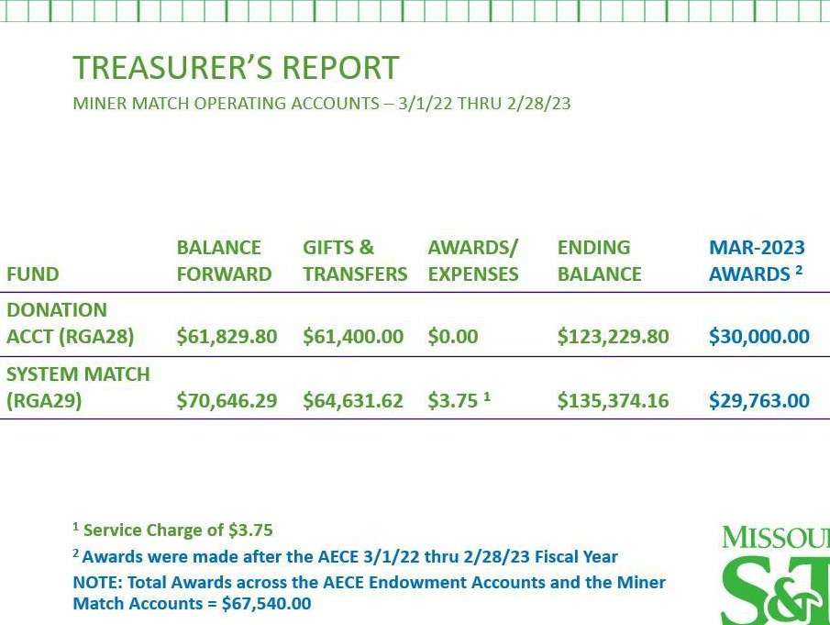

* Mark Nealon requested a list of ECE labs and asked Dr. Kimball what current needs he might have for them that might be supported by the endowment. There have been no requests made now for a few years.
* Dr. Kimball reported that some labs are in good condition and reported that after assigning responsibility to individuals that work in the labs that we should get a better understanding of what is needed soon.
  1. **Membership Committee Report**-Kenneth Owens
     + Personally welcomed, Randall Berry, Patrick Chapman, James Fonda, and Donald Ulrich, the four new Academy inductees present.
     + Reported the search for new Academy inductees would start in June.
     + Goal is to induct more members and to remind members that candidates must have at least 20 years of experience to be inducted into the Academy.
  2. **Nomination Committee/Election of Officers-** John Skain
     + Members of the committee are Vince Kunderman, James Paunicka, and John Skain.
     + Secretary/Treasurer-Tom Dalton was nominated for the position, and no other nominations were received. Don Shaw moved to approve the nomination and James Paunicka seconded. The motion passed by majority vote.
     + Board Members-Two board positions expire in 2023, but only one is currently filled, by position. Alan Erickson moved to accept the nominations, and James Paunicka seconded. The motion passed with no opposition.

### Academy Leadership into 2024

* + - President-Mark Nealon
    - Vice President-James Paunicka
    - Secretary/Treasurer-Tom Dalton
    - Board of Directors – Kelvin Erickson and Kevin McEnery (expiring in 2024), Alan Erickson and Sharon Beermann-Curtin (expiring in 2025), and John Skain and Clay Melugin (expiring in 2026)
  1. **Proposed Budget Discussion**-James Paunicka
     + Members were challenged to collectively donate $30,000 toward scholarships and encouraged to match the funds if possible.
     + Derald Morgan shared a pamphlet he had received about QCD’s and how to protect your charitable giving since the Consolidated Appropriations Act of 2023, omnibus bill has passed into law. (See copy of pamphlet attached). There was further concern expressed about the changes, and members were encouraged to contact Jason Northern for more information.
     + A discussion ensued on how scholarship moneys would be distributed by SFA to the students with the greatest need first. It was also acknowledged that the Miner match program (where the university matched funds donated by members) would no longer exist in five years.

### Budget Approval

* + - Dennis Leitterman moved to release 50K as soon as possible in order for the first Kummer Endowment of $100K to be established. The motion included a proposal to increase their spending for student organization support on campus to $1,000. -Clay Melugin seconded the motion, and the motion was passed.

### White Paper Discussion-Kenneth Owens

* + - Members discussed how to improve their membership and attendance of events.
    - Owens offered to send out a survey to members help keep track of members, which was approved.

### New Business

* + - Members discussed update the ECE Academy website, mentioning the need to correct the incorrect department minutes that were added a few months ago by mistake.
    - Questions were raised about what restrictions are in place for Kummer gifts?

### Future Meeting Date

* + - Thursday, April 11, 2024 at the Comfort Suites Conference Center

### Adjournment

* + - Dennis Leitterman moved to adjourn the business meeting, Alan Erickson seconded, and the motion was approved.